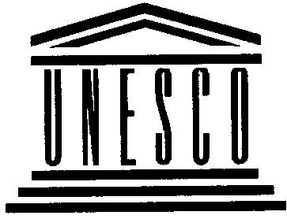
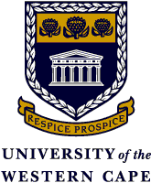

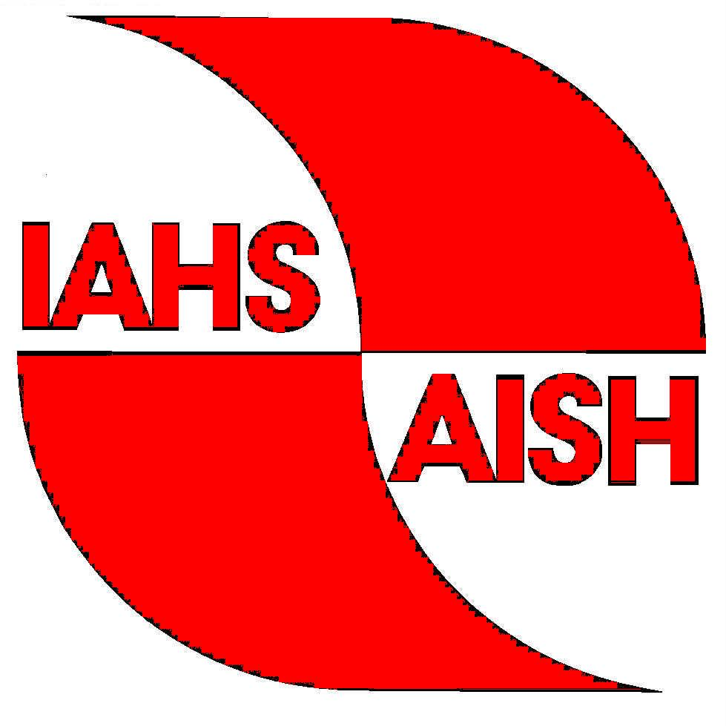


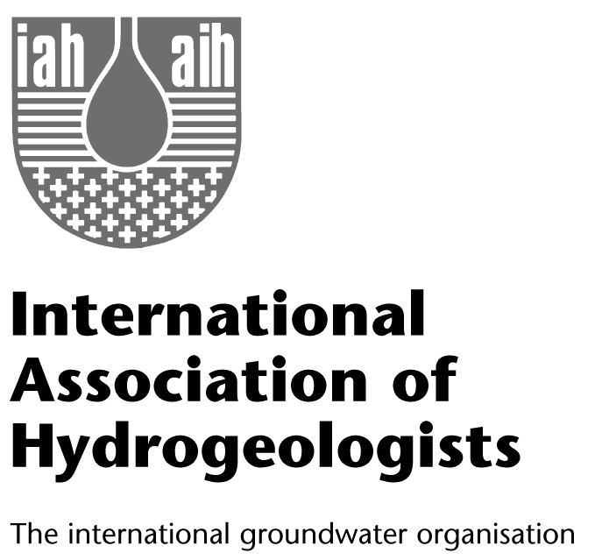
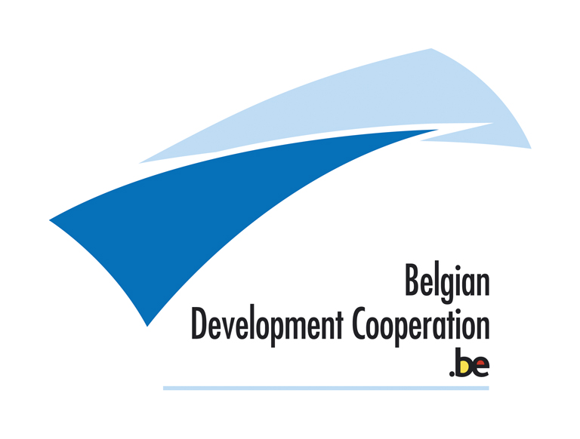
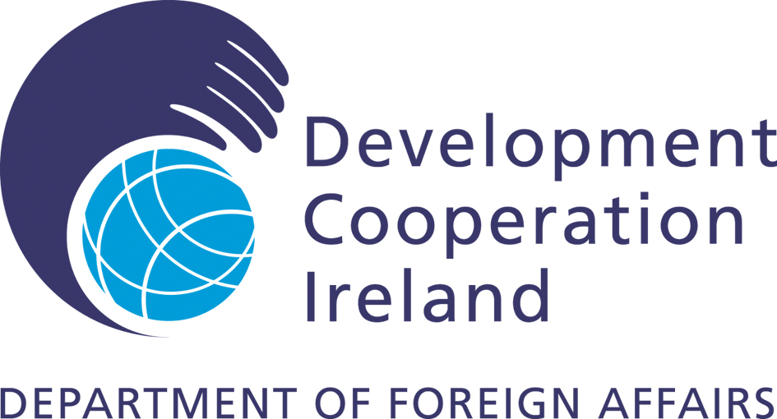
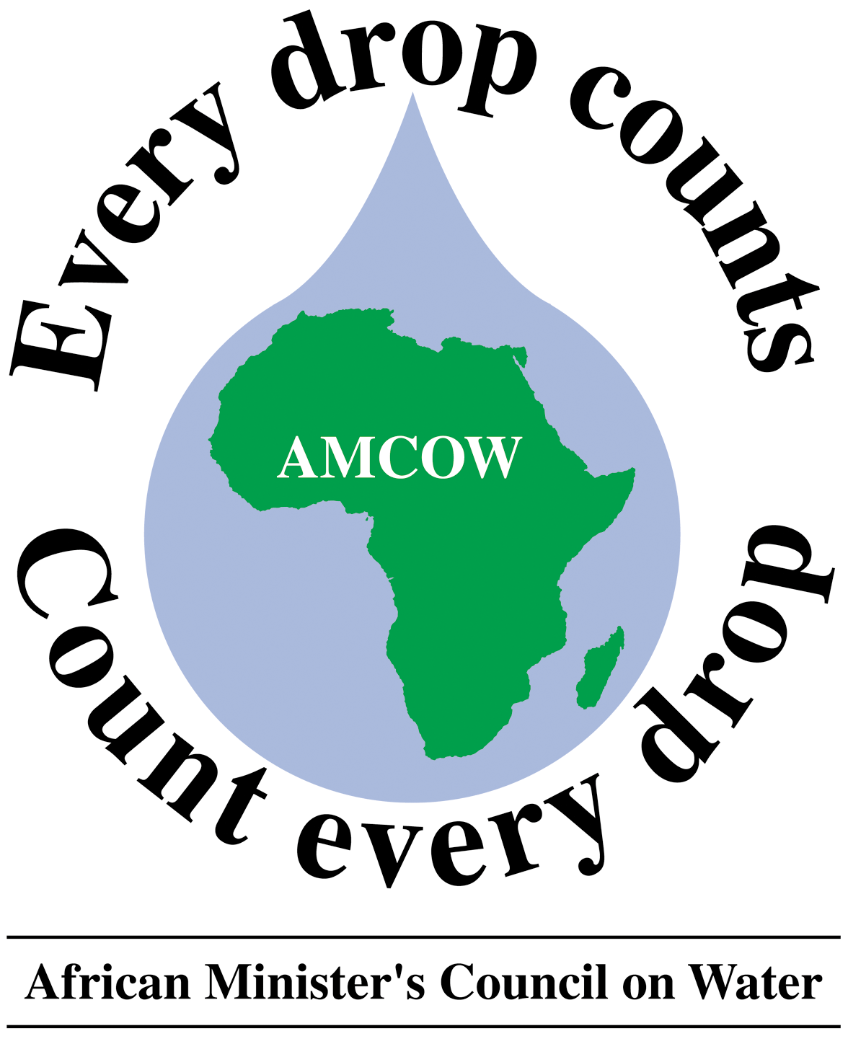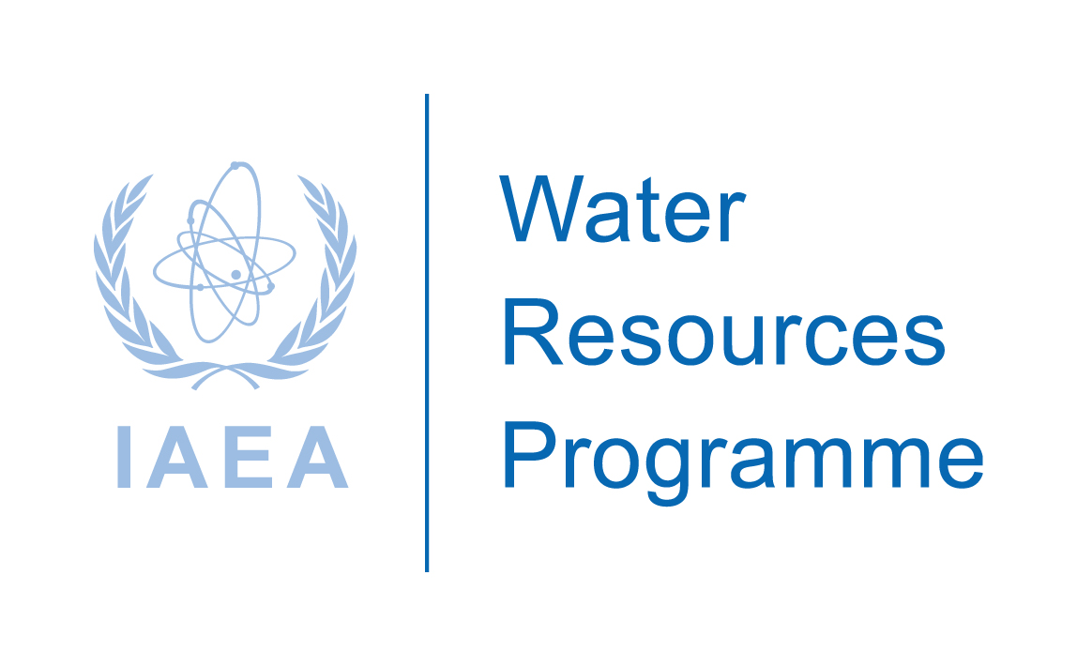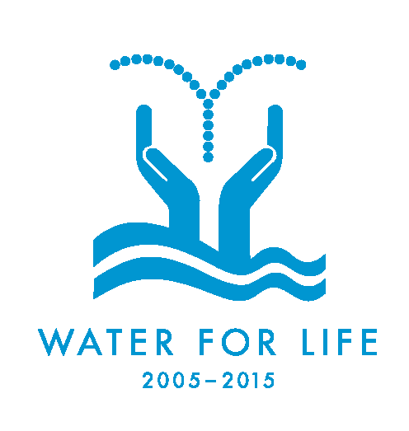


UNEP / UNESCO
South African Department of Water Affairs and Forestry
University of the Western Cape

INTERNATIONAL WORKSHOP: GROUNDWATER PROTECTION IN AFRICA

BACKGROUND:

At the Millennium Summit in 2000 and during the 2002 World Summit on Sustainable Development (WSSD) in Johannesburg, world leaders recognised the integral importance of fresh water to human development, and committed themselves to a precise, time-bound agenda for addressing the world’s current and future water resource and sanitation problems. This commitment formed a strong basis for discussion at CSD-13 on developing strategies to achieve the goal of universal safe drinking water supply, as well as providing a policy framework to leverage national and international support in support of this goal.

In this context, the New Partnership for Africa’s Development (NEPAD) Water Agenda and the constitution of the Africa Ministers’ Council on Water (AMCOW) exemplify political developments in the pursuit of this objective. At the 2003 Pan-African Implementation and Partnership Conference on Water, African ministers also examined the continent’s water challenges and recognised the multisectoral nature of water resources development in the context of socio-economic development, as well as the multi-interest utilisation of water resources for water supply and sanitation, agriculture, industry, urban development, low and flat lands management, and other activities covered by new IWRM policies to which groundwater is central.

At a regional level, groundwater is of vital importance in Africa, Asia, Central and South America. The past 50 years have seen the unprecedented development of groundwater resources in these regions. Nationally, many countries are dependent upon groundwater, with an estimated 2 billion people worldwide relying on aquifers for their drinking water supply. Numerous African countries rely on groundwater for their drinking water, both from shallow hand-dug wells and from deeper public water boreholes. In a rural context, groundwater provides the mainstay for agricultural irrigation and will be the key to providing additional resources for food security. In urban centres, groundwater supplies are important as a source of relatively low cost and generally high quality municipal and private domestic water supply.

Most of the problems affecting groundwater are associated with human development. The most common problem posing a threat to groundwater supply is degradation of the water quality due to surface-level pollution or saline intrusion. In most African countries, groundwater pollution or degradation is the main threat to the achievement of sustainable water resources management.

For the purpose of providing practical information on the environmental aspects of the management and sustainable use of groundwater resources, UNEP and UNESCO started in 2000 a joint effort with ECA and UN-HABITAT to assess groundwater vulnerability in African cities. A network of 11 countries from West, East and Southern Africa (Benin, Côte d’Ivoire, Niger, Ghana, Mali, Burkina Faso, Senegal, Ethiopia, Kenya, Zambia and South Africa) was established to develop appropriate methodologies for optimal monitoring of the pollution of urban aquifers.

Scientists, local authorities, non-governmental organisations, private business and international organisations are pooling together their efforts to improve the management of this vital resource. It is becoming increasingly obvious that the availability of groundwater resources will have a critical impact on the African Water agenda for poverty reduction.

PURPOSE: To build on the recent groundwater pollution vulnerability and risk assessment in 11 African countries as part of a major UNEP/UNESCO supported project, as well as the groundwater protection experience in a number of developing and developed countries, and work towards a groundwater protection strategy suitable to Africa’s physical and socio-economic environment.

This international workshop on groundwater protection in Africa is a joint initiative of the United Nations Environment Programme (UNEP) and the United Nations Educational Scientific and Cultural Organisation’s division of International Hydrology Programme (UNESCO/IHP) regional office in Nairobi in partnership with the Global Environment Monitoring System (GEMS) Water Programme, the University of the Western Cape (UWC), South Africa’s Water Research Commission (WRC), University of the Free State, Institute for Groundwater Studies (IGS), International Association of Hydrological Sciences (IAHS), International Atomic Energy Agency – IAEA/Water Resources Programme, United Nations UN-Water, Belgian Development Cooperation (Be), International Association of Hydrogeologist (IAH), Development Cooperation Ireland (DCI), African Ministerial Conference on Water (AMCOW), New Partnership for Africa’s Development (NEPAD) and the United Nations Human Settlements Programme (UN-HABITAT).

Specifically a project proposal will be formulated through which a groundwater protection strategy will be refined and implemented in a significant number of African countries.

DATE: 28 – 30 November 2005

VENUE: University of the Western Cape, Cape Town, South Africa

PARTICIPANTS:
- African country specialists;
- AMCOW Technical Advisory Committee;
- Regional/international experts on groundwater management in developing countries;
- Other persons with appropriate experience and interest in the protection of groundwater in Africa will be invited.

CALL FOR PAPERS:
Various thematic papers will be presented during the international workshop (see table below). Experts interested in participating in the workshop are invited to send abstracts of proposed papers for consideration. The abstracts should be not more than one page and should consist of highlights of the methodology, key findings and references. Include name/s of authors plus co-authors and contact address. All abstracts should be sent to: Jaco Nel at jmnel@uwc.ac.za

Deadline: 20th October 2005
PROVISIONAL PROGRAMME

Time | Day 1 (Chair :) | Responsibilities
8h30 – | Registration of participants | UWC team
9h30 - 11h00 | Welcome & opening ceremony  Keynote speakers | UWC-Rector  Professor K Asmal, MP  UNEP/UNESCO
11h00 – 11h30 | Tea break
11h30 – 13h30 | Session 1: GROUNDWATER VULNERABILITY AND RISKS IN AFRICA | Moderators:  Speakers:
 | - Groundwater and its susceptibility to degradation (State of the problems of groundwater use and protection; theoretical aspects of the migration of pollutants in groundwater, etc.)
 | - Scientific and technical basis of investigations in the field of groundwater protection in Africa and other developing regions
 | - Selected case studies on the assessment of groundwater vulnerability in different environments in Africa
 | - Aquifers in natural connection with rivers | (Bamako/Mali; Niamey/Niger)  (one case to be presented)
 | - Aquifers without natural connection with natural reservoirs | (Ouagadougou/ Burkina Faso, Addis Ababa/Ethiopia)  ( one case to be presented)
 | - Coastal aquifers | (Abidjan/Côte d’Ivoire, Cotonou/Benin, Mombasa/Kenya, Keita/Ghana)  (one case to be presented)
 | - Karst system aquifers | (Lusaka, Zambia)
13h30 – 14h30 | Lunch break
14h30 – 16h30 | - Other groundwater vulnerability and risk assessment initiatives/experiences around the world

 | Day 2 (Chair :)
9h30 - 11h00 | Session 2: GROUNDWATER PROTECTION | Moderators:  Speakers:
 | - Principal aspects of groundwater protection  (Groundwater protection from pollution and depletion; water-protective measures; research on groundwater pollution; delineation of supply wells, boreholes and their protection; various aspects of artificial recharge) | Prof Ken Bradbury - University of Wisconsin, USA
11h00 – 11h30 | Tea break
11h30 – 13h30 | - Groundwater protection processes  (Planning for protection, legislation, implementation, regulation, etc.)
13h30 – 14h30 | Lunch break
14h30 – 16h30 | - Groundwater protection zoning experiences and initiatives around the world

 | Day 3 (Chair :)
9h30 -  11h00 | Session 3: GROUNDWATER PROTECTION POLICIES and STRATEGIES | Moderators:  Speakers:
- Dialogue between policymakers and scientists
- Public participation, information and awareness

11h00 – 11h30 | Tea break
11h30 – 13h30 | - Elements of groundwater protection strategies  - Lessons learned
13h30 – 14h30 | Lunch break
14h30 – 16h30 | - Groundwater protection in Africa: strategy development/implementation and the way forward

Optional 2 Day Short Course

A short course has been arranged to directly follow the International Workshop. The short course will focus on the technical aspects of protection zoning. The cost of the short course is R2500 (320€) and will be held on the 1st and 2nd December 2005.
This course will guide participants to determine the size and shape of the borehole protection zone, considering the hydrogeologic characteristics of the aquifer system, and the design and operational characteristics of the boreholes used to pump water from the aquifer system. Special attention will be given to the delineation of capture zones for fractured rock aquifers.

Optional Tours

Some optional tours can be arranged at the participants’ own cost. It is currently foreseen that these tours will be after the International Workshop, but during the same time as the Short Course. The tours will visit both natural and impacted geohydrological areas. Sufficient interest in these trips will determine the arrangement of the tours.

Optional tours | Main Places Visited | Cost/person | Cost/person
Option 1 Day trip | Paarl - Wine farm  Worcester – Hot springs  Informal settlement  Cape Point | R800 | 100€
Option 2 Day trip | West coast  Atlantis water supply  Langebaan Wetlands  Swartland - Wine farm  Municipal waste site | R800 | 100€

International Organising Committee

S. Diop, UNEP (Chair); H. Drammeh, UNEP; E. Naah, UNESCO; Prof. Yongxin Xu, South Africa; Prof. Eric Odada, Kenya; S. Donkor, ECA; D. Adom, UN HABITAT; Dr. John Mugabe, NEPAD; Prof. Wolfgang Kinzelbach, Switzerland; Prof. Eberhard Braune, South Africa; Dr. Rudy Herman, Belgium; AMCOW/TAC and UN Water.

Local Organising Committee

Prof. Yongxin Xu, the University of the Western Cape (Chair); Dr. Shafick Adams, the University of the Western Cape; Mr. Jaco Nel, University of the Western Cape; Dr. Kevin Petersen, Water Research Commission; Mr. Harrison Pienaar, Department of Water Affairs and Forestry; Mr. Chris Moseki, Department of Water Affairs and Forestry; Dr. Brent Usher, the University of the Free State; Dr. Gedion Tredoux, CSIR; Mr. Rodney Bishop, City of Cape Town and Mr. Segun Adelana, IAH.
Expression of Interest – Groundwater Protection for Africa

First name: ________________________________________________

Surname: ________________________________________________

Organisation: ________________________________________________

Contact Email ________________________________________________

Reason for interest: ________________________________________________

________________________________________________

________________________________________________

Abstract of the planned contribution to the workshop (Can be attached separately):

________________________________________________

________________________________________________

________________________________________________

Optional Items:
Tick Box
2 Day Short Course
Day Trip Option 1
Day Trip Option 2
Please indicate your preference.

For more information including accommodation, please fax form to:

Fax number: +27 21 959 3118
Attention: Organising Committee

Or

Email form to

Jaco Nel at jmnel@uwc.ac.za

