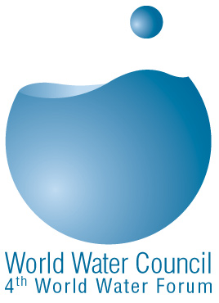 | World Water Council  Subsidy Application Form

 Identification
Name of your organization:
Member/New applicant code:
 Administrative information
Date of establishment/incorporation: City of incorporation:
Incorporation number:

Please send a certified as a true copy of your incorporation act along with your subsidy application form
● General Information:
Please provide a description of your most relevant activities (programmes and projects) related to water and sanitation. For each activity, please, indicate clearly its expected outcomes, its duration, its status (planned, underway, achieved) its geographical zones, its type of financing, your partner and sponsor organisations. (If you do not have enough room you may use a separate sheet of paper):

❍ Statement
Why your organisation should be considered for receiving a subsidy for its membership fees?

We hereby confirm having read and understood the membership Solidarity Fund procedure
We hereby confirm our commitment to paying the remaining part of the membership fees if we are granted the subsidy
Date:
Name and signature of the CEO, president or equivalent: | Stamp of the organisation

Important: In order to validate your application you must return along with this form:
- A certified as true copy of your incorporation act
- A draft cheque to cover your share of your membership fees addressed to the World Water Council. This cheque will be cashed if you are granted the subsidy or will be returned to you.
- Any additional documents you may feel relevant to your application such as auditor report, annual activities report, press-releases, brochures, etc…
Please return the original of this form, duly filled in and signed, along with requested document and your check to:
World Water Council
Espace Gaymard, 2-4 place d’Avrieux
13002 Marseille – FRANCE

