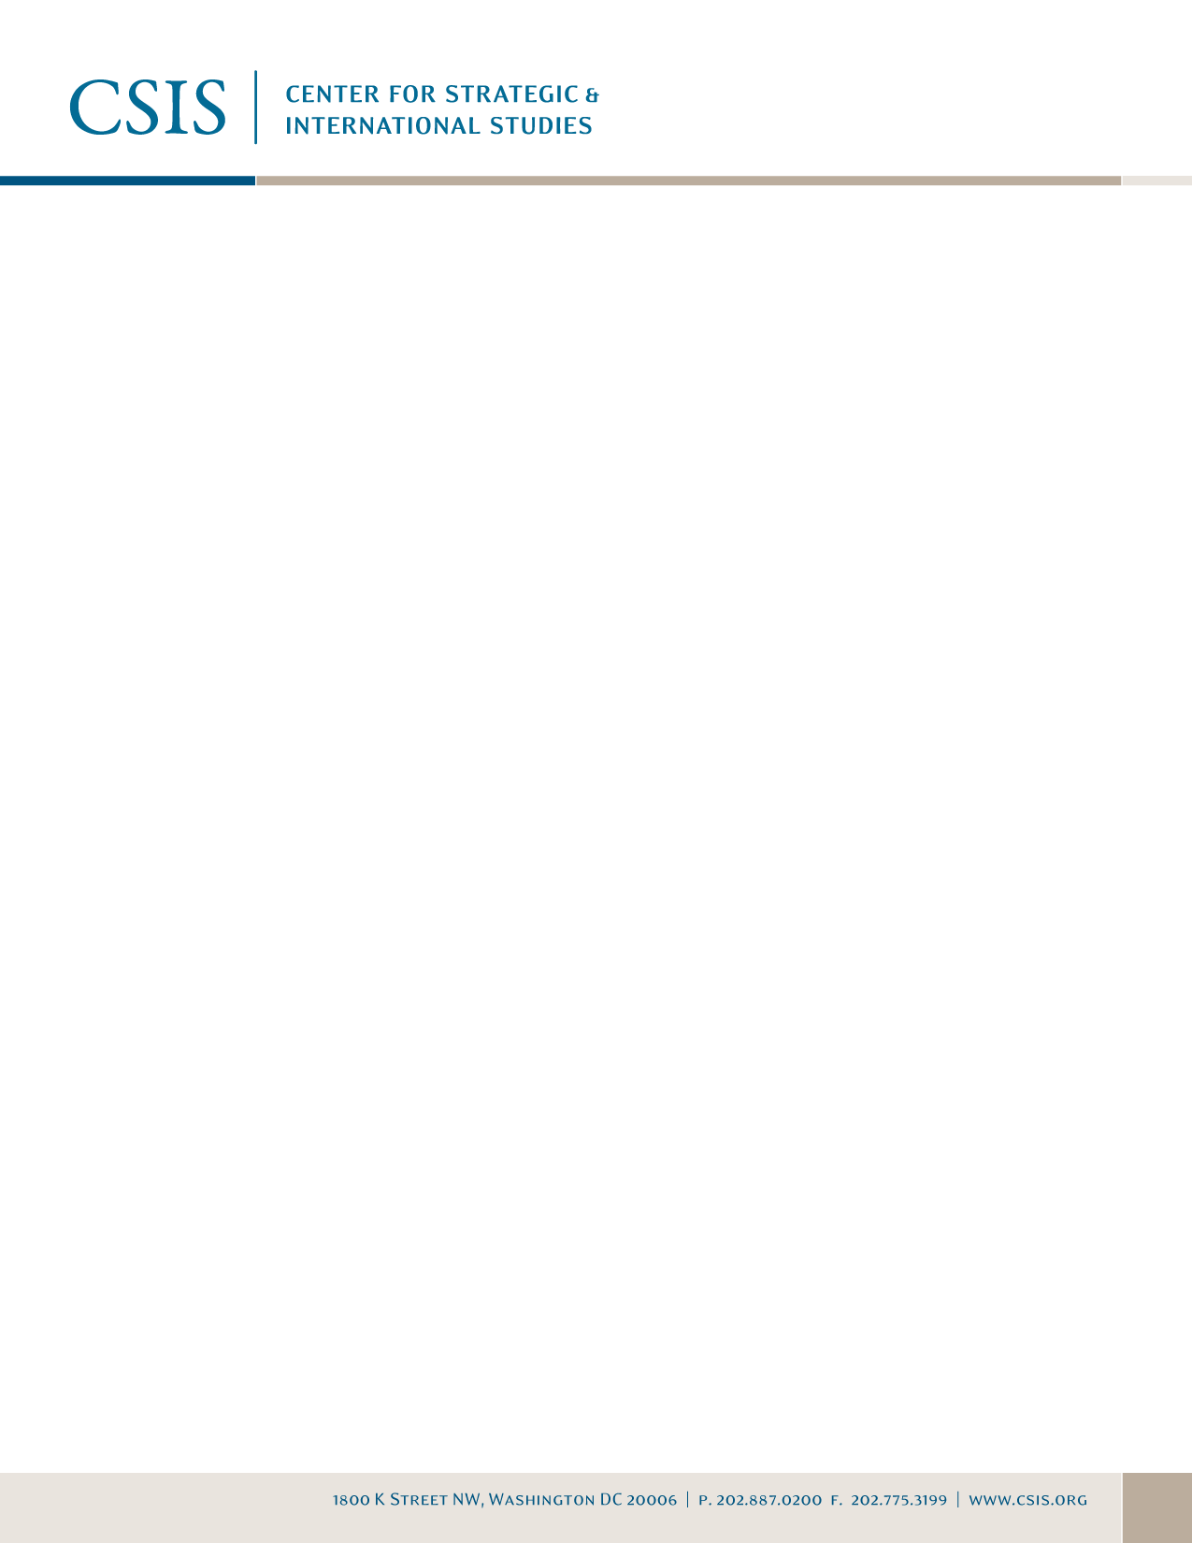

A Conversation with Loïc Fauchon,
President, World Water Council

Summary
On Monday, October 27, 2008, CSIS was pleased to welcome Loïc Fauchon, president of the World Water Council, for a high-level roundtable discussion with leaders in the water policy community. Mr. Fauchon offered remarks synthesizing the socio-political state of water in the world, and also discussed preparations for the Fifth World Water Forum.

To begin, Mr. Fauchon asserted that water is a strategic resource that directly links to security, stability, and peace—political leaders from around the world need to remember that mastering water resources is the key to human development and peace. He warned that governments should not use water or energy as cost-saving mechanisms (in light of the current economic crisis) but rather maintain a strategic focus on these resources as they so closely tie to security issues. He explained, for example, that shanty towns and suburban slums lacking access to water, sanitation, and other basic services generate an environment where distressed, young people are ripe for terrorist recruitment. One novel solution to this problem is King Mohamed VI of Morocco’s National Human Development Initiative (INDH). This nation-wide, inclusive program recognizes the dignity of the poorest people and seeks to provide all citizens with free access to water, sanitation, electricity, and education. However, this model is not guaranteed to work everywhere. Mr. Fauchon argued that although the water crisis is global in nature, it requires geographically tailored, localized solutions. The “one-size-fits-all” approach will only bring about the same development failures that we have already seen in past decades.

Mr. Fauchon then outlined the four main global problems driving the water crisis:
- Demographic pressures on water supplies;
- Globalization- and urbanization-related pollution and sanitation issues;
- Economic-related pressures for food production and industry; and
- Climate evolutions.

He noted that our main obligation and challenge is to ensure sufficient water in every place and at every time when water is needed. Mr. Fauchon then presented his five “big imperatives” for achieving progress in the water world:
- Legal;
- Economic;
- Democratic;
- Educational; and
- Technological.

To close, Mr. Fauchon presented his 10 key messages on behalf of the World Water Council:
- Water is a strategic resource, for both health and humanitarian reasons.
- Water is a global and a local problem.
- Climate is not the main difficulty.
- The role of energy is still a major factor, regarding energy used for water as well as infrastructure challenges. Potential solutions include:
  - Establishing a moratorium on the price of energy used for water;
  - Creating a new type of fuel for water; and
  - Levying a tax on the price of energy for water, such as a one percent tax for irrigation.
- The competing uses for water—such as health, business, food, biodiversity, and conservation—have different requirements. Water needs a high political authority, like a water advisory group, for government leaders to utilize in their decision-making processes.
- The role of local water authorities and cities needs to be recognized because they are ultimately responsible for delivering water and sanitation services to citizens.
- The individual, human right to water should be formally, constitutionally recognized in every country across the globe.
- Tony Allan’s concept of virtual water trade should be put into practice, whereby water-intensive goods are exported from water-rich areas and imported by water-poor regions.
- We need a new culture around water and a demand-driven approach to bring water and sanitation to the developing world.
- Political leaders across the globe should develop a new water consciousness and strive together for world water equity.

Group Discussion
In the conversation following his formal remarks, Mr. Fauchon and his colleagues from the World Water Council Board of Governors discussed plans for the Fifth World Water Forum in Istanbul in March of 2009. The Forum will include a new political process to engage heads of state, parliamentarians, and mayors of the world’s biggest cities in an ongoing water dialogue. For example, through the Forum’s “Istanbul Consensus,” cities will outline how to react to water crises. The World Water Council particularly intends to work with governors from across the globe to address local water problems.

Beyond the World Water Forum, Mr. Fauchon highlighted the need for national water initiatives, similar to the Japanese Water Forum, which can bring together government agencies, NGOs, and other stakeholders in the water realm to unite under a common goal (and a common flag). He also called for a stronger international effort to bring water and sanitation services to schools in the developing world.

