
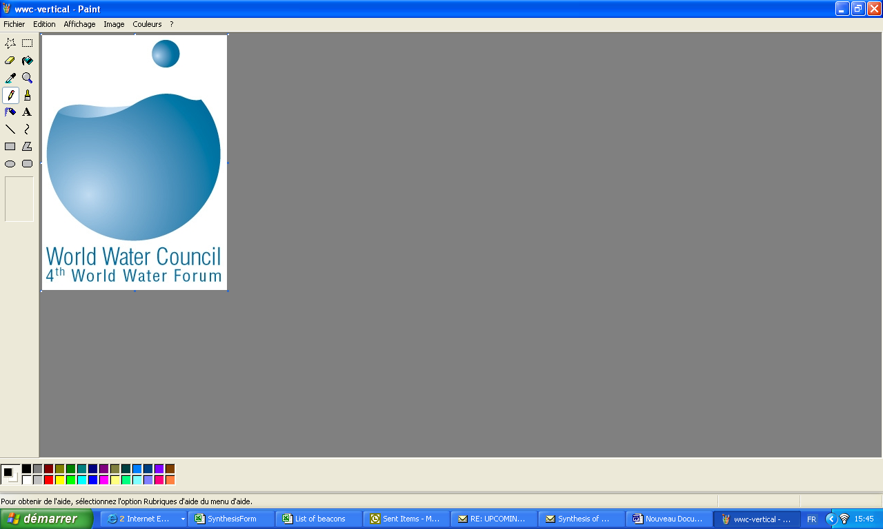
“Your views are important for us”

World Water Forum

Preparing the Future

This questionnaire is designed to help us prepare the future World Water Fora. Please fill it in and bring it back to the World Water Council stand. You can also download this questionnaire from www.worldwatercouncil.org and send it back to feedback@worldwatercouncil.org

4th World Water Forum

 | 1 = strongly disagree, 5 = strongly agree
 |  | 1 | 2 | 3 | 4 | 5
1 | Intent: I have come to the Forum to:
1.1 | learn about water issues
1.2 | meet with water colleagues, establish new partnerships
1.3 | promote and advocate ideas
1.4 | promote new projects, products or services
1.5 | Other (explain)
2 | Content
2.1 | I have found sufficient substantive content in the Forum
2.2 | The majority of the issues addressed are cutting edge
2.3 | I have learned about new water issues at the Forum
2.4 | The Forum programme makes it easy to choose between sessions
2.5 | The theme of the Forum attracted me to attend the Forum
2.6 | I have participated in the preparatory process in the regions
2.7 | I have participated in the preparation of the 4WWF thematic work
3 | Networking
3.1 | I have good networking opportunities at the Forum
3.2 | The current Forum sessions format helps me to network
3.3 | The Fair is a critical part of the Forum for networking
3.4 | The Expo is a critical part associated with the Forum
3.5 | The Ministerial Conference is important for the Forum
3.6 | More networking opportunities need to be provided
4 | Organisation
4.1 | My registration and bookings were done smoothly
4.2 | I have had easy access to the organisers
4.3 | I have been able to attend the sessions I wanted
4.4 | The facilities are well suited for the Forum
4.5 | The signalling throughout the Forum is good
4.6 | The restaurant and beverage facilities are good
4.7 | The transport from and to hotels is well organised
5 | Final remarks
5.1 | Attending the Forum was worth my time, effort and resources
5.2 | I will attend the 5th Wold Water Forum

Which events did you attend?

Official thematic sessions □
Side events □
Film festival □
Alternative Forum □
Media activities □
Others □

Previous World Water Fora (if you did not attend any previous Water Forum, please skip this section)

 | 1 = strongly disagree, 5 = strongly agree
 |  | 1 | 2 | 3 | 4 | 5
 | The previous Fora had positive outcomes in terms of:
1.1 | Better understanding of the issues
1.2 | New partnerships
1.3 | New projects initiated
1.4 | Other (explain)

Future World Water Fora

Which frequency (tick the most appropriate)
Every two years □
Every three years □
Every four years □
Every five years □

Other Comments

About you
Organisation:
Intergovernmental □ Local or national government □ Parliamentarian □
Private company □ Public Utility □ Media □ Civil Society □
Research/education □ Professional network □ Other □
Member of WWC YES □ NO □

Age : <30 □ 30-40 □ 40-50 □ 50-60 □ >60 □
Gender: M □ F □
Country

REGION: Africa □ Austral-Asia □ Europe □
Middle East □ Americas □

Optional: Name: E-mail

Thank you for taking the time to complete this questionnaire!

