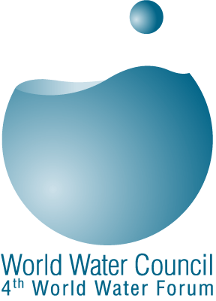


World Water Council
PRESS RELEASE
Dr. Torkil Jønch –Clausen from Denmark
wins 2006 King Hassan Great World Water Prize

Mexico, March 16, 2006 - For its second edition, the King Hassan Great World Water Prize has been awarded to Dr. Torkil Jønch -Clausen of DHI Water and Environment in Denmark, for his outstanding contributions to advancing integrated water resources management (IWRM) at the global scale. The award ceremony took place during the opening ceremony of the 4th World Water Forum in Mexico City, on March 16.

A technology-engineering manager, Dr. Torkil Jønch-Clausen is also a UN professional for UNEP. He was one of the founders of the Global Water Partnership, for which he is now international organizer.

He has contributed to the development and promotion of IWRM worldwide and greatly influenced the international agenda. He participated in the establishment of the operational IWRM concept encompassing the three pillars: Enabling environment, institutional roles and management instruments. On the ground, he has been particularly active advising on IWRM programmes in the Mekong river basin, Burkina Faso, Nicaragua and Vietnam, just to name a few.

The King Hassan Great World Water Prize is a common initiative of the World Water Council and the government of the Kingdom of Morocco. It was established in 2000 as a political tool to promote good water management and reward individuals or organisations contribution to advance the cause of water. It was presented for the first time at the 3rd World Water Forum in Kyoto.

In Kyoto, Dr. Torkil Jønch-Clausen was the organiser and coordinator of the IWRM theme, the largest theme with over 40 sessions, and in Mexico he has been the beacon for IWRM, one of the five main themes of the Forum.

Press contact, Stephanie Porro, World Water Council, Ph. 044 55 29 06 70 04

