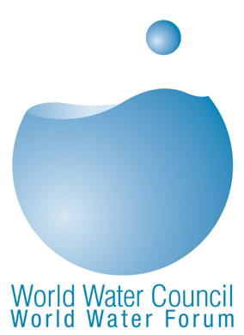 | Press Contact: m.giard@worldwatercouncil.org  Tel: +33 (0)4.91.99.41.00
 | Press Contact: foraffairs@dsi.gov.tr  Tel +90 (312) 4254614  Journalists interested in attending the launch and press conference in Istanbul on March 20th should contact DSI or the World Water Council.

Tuesday, 30 January 2007

Turkey to Host the 5th World Water Forum in 2009

Ankara, Turkey — On Thursday 18 January, Turkey and the World Water Council (WWC) signed the official agreement for the organisation of the 5th World Water Forum, to be held in Istanbul from 15 to 22 March 2009.

At the signing ceremony in Ankara, Dr. M. Hilmi Güler, Turkish Minister of Energy and Natural Resources, stated that 15,000 people from 150 countries are expected to attend the 5th Forum to discuss issues and solutions regarding water in the world. Emphasizing the crucial role of water for people, life, energy and balance in the world, Dr. Güler reported that serious measures are being taken in Turkey in this respect. He cited the example of a recent law on renewable energy in Turkey and qualified it as an important step, or even a milestone. Dr. Veysel Eroglu, Director General of State Hydraulic Works, the organization that will lead the Forum preparation, stated his conviction that the 5th World Water Forum will mark an evolution, referring to “before Istanbul” and ”after Istanbul.”

Meanwhile, Mr. Paul Reiter, Chair of the selection committee of the World Water Council, based in Marseilles, expressed his satisfaction that the 5th World Water Forum would be held in Turkey: “Turkey has demonstrated that it is fully committed to organizing a successful Forum and we are confident that the preparatory process will lead to a very productive event.” The two-year preparatory process involving representatives from numerous international institutions and ministries will supply new and relevant content for debate and proposals and will be launched on the 19th and 20th of March in Istanbul.

The President of the World Water Council, Mr. Loïc Fauchon, emphasized that water should be a greater priority. "We wish that all the research and investments made on cell phones over the past 10 years would be made for water too! We can survive without cell phones, but we cannot survive without water." The WWC President also added that increasing population, pollution of water resources and the increased need for water due to climate change constitute the three main water-related problems facing the world today.

The World Water Forum, which is organized by the WWC every three years in collaboration with the authorities of the host country, is the largest international event in the field of water. The 4th World Water Forum was held in Mexico in March 2006.

