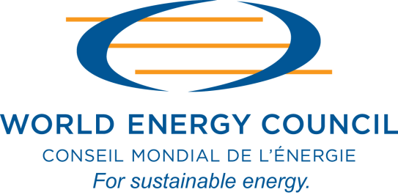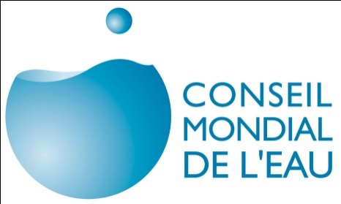

**PRESS RELEASE**

**World Energy Council and World Water Council join forces to encourage public policy to address the “water-energy nexus”**

**Marseille, Tuesday, March 13, 2012 – The strong connexion between energy and water requires regular dialogue and the sharing of experiences and solutions. Now, their ever more interlinked future brings our two organisations together to tackle the world’s energy and water challenges.**

At the 6th World Water Forum held this week in Marseille, France, Pierre Gadonneix, Chairman of the World Energy Council (WEC), and Loïc Fauchon, Chairman of the World Water Council, announced their commitment to cooperate in the long-term to promote greater energy efficiency in the management of water, recognise and improve energy usage in the water sector, and facilitate cross-sector dialogue. This announcement is the result of the longstanding commitment of both chairmen to develop a long-term partnership following a series of regular exchanges they had held since 2009.

Under the cooperation, the two organisations will:

* Share data, studies, and information, and contribute to their mutual visibility , including:
  + Studies by the World Energy Council: *Energy for Water (2010*); *Policy Assessment: Review of Energy and Climate Policies*; *Energy Policy* *Scenarios to 2050*; and *Energy and* *Urban Innovation*
  + The ongoing work, *Water and Green Growth,* led by the World Water Council and the South Korean government
* Discuss and consult with each other on future studies and research on water and energy
* Ensure that both water and energy are considered in the work of both organisations
* Organise specific sessions or workshops in the core programmes of both organisations’ World Congresses
* Advance tangible solutions on both local and regional levels
* Promote the communication on issues related to the "water–energy nexus"

On this occasion, **Pierre Gadonneix, President of World Energy Council, says:**

*“Water and energy have a unique relationship made of mutual interactions, one being either a vulnerability or an opportunity to the other. More importantly, they face similar long-term challenges in terms of rising demand – driven by demographic growth and pulled by global development – and addressing the issues of climate change, energy and water poverty which constitute fundamental barriers to human development.*

*“Both sectors also have comparable opportunities, especially in terms of the resources and technologies that are available to us to address those challenges: the important potential for efficiency to mitigate the growth of demand, resources which are numerous but concentrated and increasingly difficult to access, more sophisticated technologies which are also more expensive, and eventually massive and urgent investment needs.*

*“Therefore, similar and coordinated solutions and policies should be developed in terms of governance on both national and international levels. This has been the driver for our decision to strengthen the collaboration between the World Water Council and the World Energy Council.”*

**Loïc Fauchon, President of the World Water Council, adds:**

*“At the heart of climate negotiations, we need to shift from the concept of energy-climate towards one of energy-water. Recognising the nexus between water and energy will translate into greater funding for water infrastructure. Energy and water both lie at the heart of securing tomorrow’s world."*

**About the World Energy Council**

The World Energy Council (WEC) is the principal impartial network of leaders and practitioners promoting an affordable, stable and environmentally sensitive energy system for the greatest benefit of all. Formed in 1923, WEC is the UN-accredited global energy body, representing the entire energy spectrum, with more than 3000 member organisations located in over 90 countries and drawn from governments, private and state corporations, academia, NGOs and energy-related stakeholders. WEC informs global, regional and national energy strategies by hosting high-level events, publishing authoritative studies and working through its extensive member network to facilitate the energy policy dialogue.

Further details at [www.worldenergy.org](http://www.worldenergy.org) and @WECouncil

**About the World Water Council**

The World Water Council was established in1996 by several States and international organizations to sensitize both public opinion and international political authorities to bring the cause of water forward.   
The World Water Council, which has its headquarters in Marseille, brings together around 350 organizations from more than 70 different countries. As a major international organisation dealing with global water issues, the World Water Council co-hosts alongside France and Marseille the 6th World Water Forum – from 12to 17 March 2012 - around the theme “*Solutions for Water*”, seeking to identify, promote and develop concrete solutions for water.

For more information: [www.worldwatercouncil.org](http://www.worldwatercouncil.org) @Wwatercouncil facebook.com/worldwatercouncil

**Press contacts:**

**World Energy Council Grayling France for the World Water Council**

Florence Mazzone Daniel Da Costa / Anne-Sophie Cahuzac

Tel: +44 207 292 2090 Tel.: 01 55 30 70 90/70 93

[mazzone@worldenergy.org](mailto:mazzone@worldenergy.org) [daniel.dacosta@grayling.com](mailto:daniel.dacosta@grayling.com)

[annesophie.cahuzac@grayling.com](mailto:annesophie.cahuzac@grayling.com)