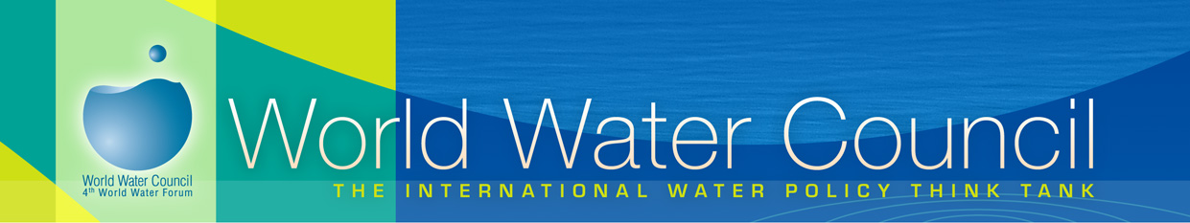

This form was designed in the context of the tsunami which hit the South of Asia on December 26, and aims at inventorying both the actions and the needs which exist in the field of water supply and sanitation. Once you have filled it in, please send it the World Water Council Headquarters at s.andre@worldwatercouncil.org.
Identification
Name of your organization:
Acronym / abbreviation: Country of origin:
1. Details of the Action(s) being undertaken
Is your action? planned or underway
Is it a: emergency action medium term action long term action
Geographical zone of action. Please specify the provinces, cities, villages or where you are working:
Indonesia
Thailand
Sri Lanka
Malaysia
India
African east coast:
population concerned: 1<<1000 people 1000<<5000 5000<<10000 10000>>
Expected duration: Starting date: Finishing date:
Details of your action (If you do not have enough room, you may use a separate sheet of paper):

2. Needs  (Needs of actors who are already involved or are about to get involved in relief action)  What is/are your geographical zone(s) of action?  Indonesia Thailand Sri Lanka Malaysia India African east coast countries  What time period are you working on?  Emergency Medium term Long term  Is your project? Planned Underway  What do you need?  Financial support  Human resources  Expertise and knowledge  Equipment  Please specify your needs (If you do not have enough room, you may use a separate sheet of paper.) |  | 3. Offers  (Types of assistance that may be provided)  What time period are you willing to help on:  Emergency Medium term Long term  How may you assist organisations involved?  Financial support  Human resources  Expertise and knowledge  Equipment  Please specify your contribution (If you do not have enough room you may use a separate sheet of paper.
Contact details
Contact person 1: |  |  |  | E-mail:
Contact person #2: |  |  |  | E-mail:
Address :
City: | Post code: |  | Province: |  | Country:
Tel: |  |  | Fax:
Website:
I agree to the WWC using the information provided on World Water Council’s website and newsletter
I agree to you making the e-mail address of the contact person visible for the public at large
I wish to receive the general newsletter of the World Water Council

