ABOUT US PARTNERS EVENTS S ATELLITE WEBSITES KEYWORDS SEARCH
1
KEY PROGRAMS
- Water for development
- Strengthening local stakeholders
- Interlinking monitoring

ASSOCIATED PROGRAMS
- Water Co-operation Facility
- Cooperative Program on Water & Climate
- Northern Water Network
- Water & Cultural diversity

WORLD WATER FORUM
- Accomplishments
- Next Forum
- Previous For a

WATER IN THE WORLD
- Water crisis
- Millennium Development Goals
- Water supply & sanitation
- Water for food
- Water & nature
- Water & financing infrastructure
- Water & politics

NEWS
- Newsletter
- News archives

LIBRARY
- Publications & reports
- Water Policy Journal
- Official declarations
- Points of view
- Links

2
FOCUS ON

4th World Water Forum – Mexico – March 2006

Water Media Program

Financing Water
for All

World Water Actions

World Water Vision

PRIZE

King Hassan II Great World Water Prize

Kyoto Water Prize
3
Jobs & training
Contact Site map Last update on : Copy rights
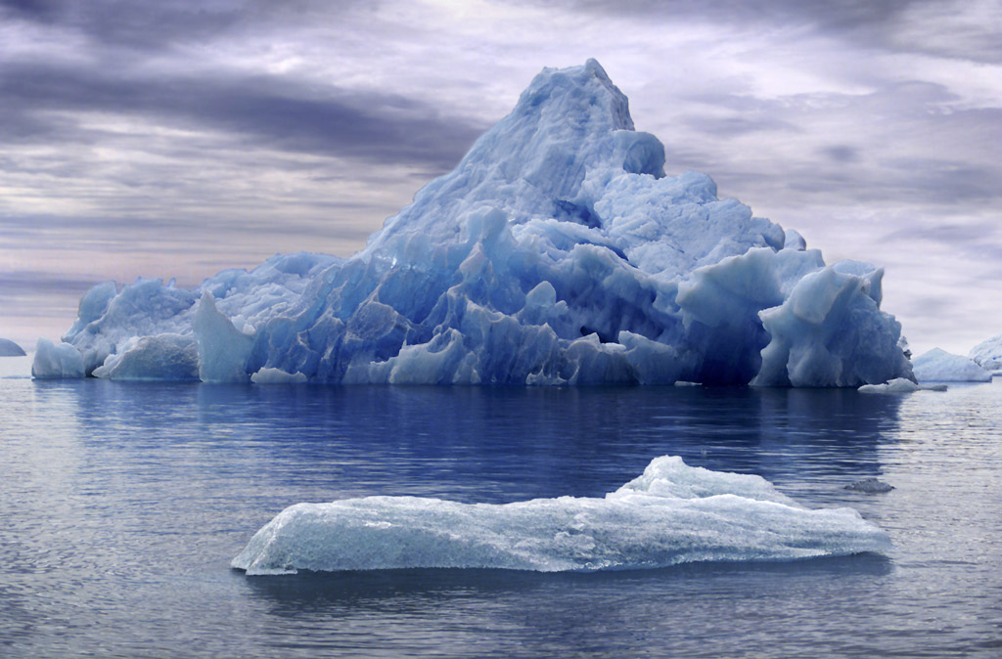 What is the World Water Council What is the World Water Council What is the World Water Council What is the World Water Council What is the World Water Council What is the World Water Council More

Point of view

Can virtual water contribute to water security in the 21st century?
Read the opinions of worldwide experts Daniel Renault (FAO), Tony Allan (School of African and Oriental Studies, London), Arjen Hoekstra (IHE) and Ramon Lalmas (Spain's Royal Academy of Sciences)
This trimester, the Water Policy Journal features articles on: Challenges for water sector reform in transition economies, utility-small water enterprise partner-ships … More
21/12/04 - WWC President William Cosgrove announces his resignation
William Cosgrove informed the members of the Council of his resignation from the Presidency and the Board of Governors of the Council effective January 7, 2005 to take up the position of President of the Bureau des audiences publiques sur l'environnement in Québec. More

05/12/05 - Condolences to the people of the South Asian region
On December 26, an earthquake measuring 9.0 magnitude with its epicenter located at the western end of Indonesia's Sumatra Island struck the south of Asia. This earthquake unleashed a series of tsunamis that crashed into coastal towns, fishing villages and tourist resorts from Sri Lanka to India, Thailand, Indonesia and Malaysia. The tsunamis killed over 150.000 people, left hundreds of thousands injured and homeless. It is with great emotion that …. More
Subscribe to our Newsletter
BECOME A MEMBER
English Francais

