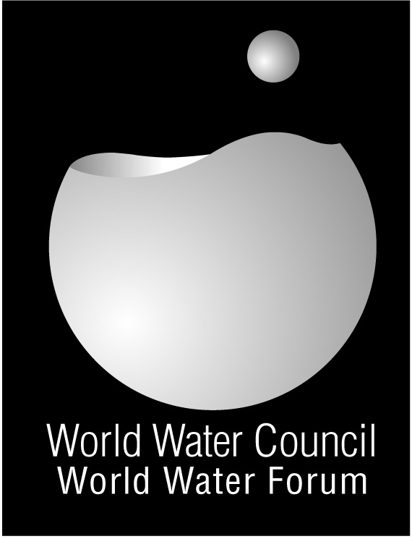

From Mexico to Istanbul

The Hashimoto Action Plan

Triggering progress on 6 major issues

- Find the Financing for Water
- Do something real about Sanitation
- Monitor to know where we progress – and don’t
- Improve Water Operators Functioning and Finance Access
- Integrated Water Resources Management
- Avert the Damage in Water Related Disasters

Major achievements

Find the Financing for Water:
Donors and regional development banks have been contacted to ensure increased access to financial resources by local institutions. G8 and African Union countries were lobbied to ensure water remains high on their agendas. UNSGAB promoted access to local finance markets for water utilities.

Do something real about Sanitation:
The International year of Sanitation was promoted and then endorsed by the UN General Assembly. It has helped to break the sanitation taboo and build momentum around the issue of sanitation in all regions of the world.
http://sanitationyear2008.org

Monitor progress:
UNSGAB advocated for increased support to the Joint Monitoring Programme of the UN and for complementary data now delivered through the GLAAS report. It worked with the OECD to improve monitoring of Official Development Aid to water

Water Operators Functioning and Finance Access:
A global alliance of technical water service providers and financers was created in order to improve local water services. The Global Water Operators partnership Alliance is being implemented by UN-Habitat. UNSGAB also encouraged donor support for the initiative.

Integrated Water Resources Management (IWRM):
National Plans for IWRM, a framework to help water managers to develop and manage water resources, were requested in the Johannesburg Plan of Implementation. UNSGAB asked the UN Secretary General to request countries to report on their plans in 2008 – which they did. UNSGAB also promoted the development of transboundary water agreements.

Water related Disasters:
UNSGAB created a High-Level Expert Panel on Water and Disasters to prepare a specific action plan to reduce the number of victims of water related disasters. The High Level Expert Panel reports on their proposed actions during the 5th World Water Forum

The Hashimoto Action Plan, prepared by UNSGAB, was officially launched during the 4th World Water Forum in Mexico. This Action Plan has been promoted in high level meetings to ensure water features high in the political priorities

UNSGAB is the United Nations Secretary-General’s Advisory Board on Water and Sanitation

It is composed of 23 world-renowned high-level experts

UNSGAB is mainly playing an advocacy role in decision making circles.

Contact F.Guerquin, Coordinator
guerquin@un.org

http://www.unsgab.org/index.htm
Sharm El-Sheik Declaration
In 2008 UNSGAB was instrumental in having the African Union convene its first summit dedicated to water and sanitation. The event resulted in a binding declaration with concrete targets.

http://www.unsgab.org/news/docs/080701_AUDeclarationSeS.pdf

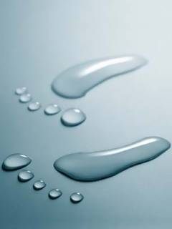
Water Operators Partnerships promote exchange of experience and cooperation between water services providers in order to improve service delivery, sound cost recovery mechanisms, operation and maintenance, with special emphasis on ensuring access by the poor.

http://www.unhabitat.org/categories.asp?catid=568

