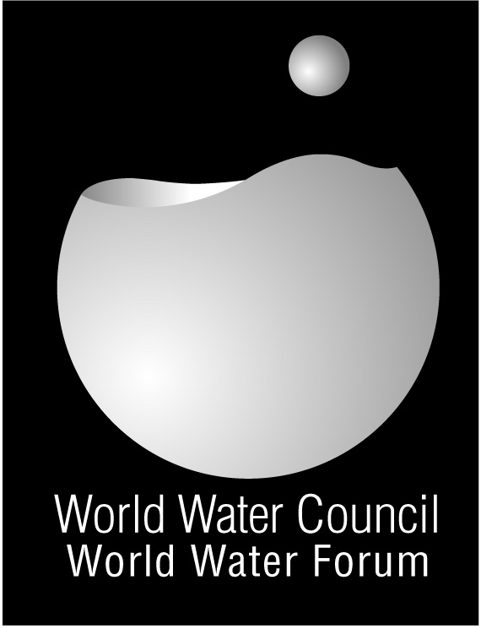

From Mexico to Istanbul

What impacts of the Forum on the host country?

Major changes triggered by the Forum

- Water is higher on the agenda.
- Increasing resources made available from public budget
- Major water projects have been initiated.
- Local projects are reinforced
- Water operators get mobilized
- An academic forum created to support public decision

Water higher on the agenda

Thanks to the Forum and its high exposure in the Mexican society, decision makers and people have become more water-sensitive. For instance, water in Mexico is considered as a strategic national resource.

Increasing resources made available from public budget

After the Forum, the financial resources for the water sector have increased each year in a very important way and budget allocated in 2009 is more than two times the budget assigned in 2006.

Major water projects have been initiated

Over the past three years, new major projects have been developed related to the efficient use of water in agriculture and to water supply and sanitation. One of the examples is the construction of a new deep sewerage tunnel and six wastewater treatment plants in the Valley of Mexico (see box).

Local projects are reinforced

Accordingly to the 4th World Water Forum motto “Local actions for a global challenge”, integrated local water projects based on public participation have been launched nationwide. Mexican universities are the leading organizations of these projects at the planning stage in close collaboration with international organizations such as WWF, WB, JICA and GTZ.

Water operators get mobilized

Water utilities have built on the momentum of the Forum to launch initiatives aiming at improving their performances. Additionally, new programs have been implemented by the Federal Government in order to promote the treatment of wastewater by municipalities.

Creation of an academic Forum

The National Autonomous University of Mexico created an academic water forum to propose policies, strategies and ways to solve the most important water problems of the country. It has become a very important think thank force from the academic world.

CONAGUA is the National Water Agency of Mexico and jointly with WWC organised the 4th World Water Forum. Its mission is to administrate and preserve the national water resources, including the participation of the Mexican people in order to reach a sustainable use of water.

Contact:
josea.rodriguez@conagua.gob.mx

ANEAS is the Mexican Association of Water Operators, a private organization, that took part in the preparation of the 4th World Water Forum

Contact:
roberto.olivares@aneas.com.mx

ANUR is the National Association for Irrigation Users of MEXICO, a private organization, that took part in the preparation of the 4th World Water Forum

Contact:
anur_yuso@yahoo.com

The National Autonomous University of Mexico is the oldest university of America and is recognized worldwide for its academic level.

Contact:
fgv@pumas.iingen.unam.mx

Waste Water Treatment in the Valley of Mexico
In order to reinforce the drainage system of Mexico City, the deep Eastern Outfall Tunnel is currently under construction. The tunnel will be 62 kilometers in length, seven meters in diameter and will carry on an average of 150 cubic meters per second.

This monumental public work of engineering will reduce the risk of flooding in Mexico City and its metropolitan area, ensuring the safety of its 20 million inhabitants.
In addition, six treatment plants will be constructed with a total capacity of 40 m³/s, in order to treat all the wastewater produced.

