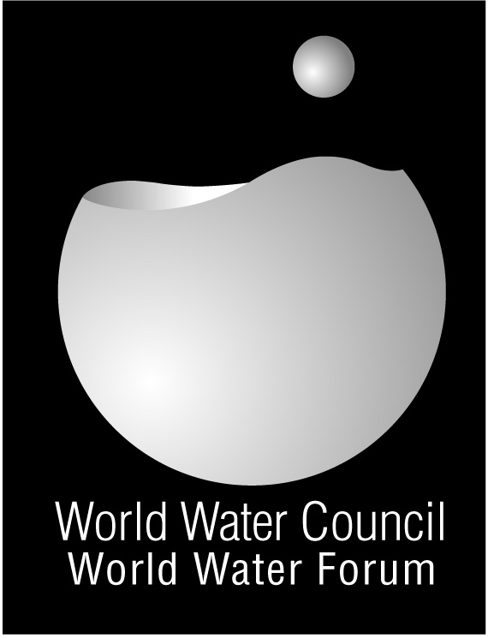

From Mexico to Istanbul

Implementing the Right to Water

Major achievements
- The Un Human Rights Council addresses the right to water
- Several international declarations demonstrate that countries commit to right to water approaches
- The right to water is increasingly recognized and implemented in national legislation

International declarations
The Summit of the Non-Aligned Movement in Havana (September 2006), attended by ministers of 116 developing countries officially supports the right to water approach. September 2006
At the First Summit of Africa-South America held in Abuja (Nigeria), the Heads of State declare that: “We shall promote the right of our citizens to have access to clean and safe water and sanitation within our respective jurisdictions.” November 2006
In the Beppu Declaration, the representatives of 36 States of the Asia Pacific region including China, India, Indonesia and Japan state that they recognise: "the people's right to safe drinking water and basic sanitation as a basic human right and a fundamental aspect of human security." December 2007
Advocacy campaign by COHRE and partners FANSA and
WaterAid bears fruit as SACOSAN States reaffirm the right to water in the Delhi
Declaration November 2008
National legislation
- Spain: The statutes of regional autonomy of Aragon and Valencia have incorporated the right to water as early as 2006.
- Belgian Parliament has agreed to introduce the right to water in the constitution at its next constitutional revision. In October 2006 a law establishes the principle of affordability of water bill
- Bolivia, Congo, Ecuador, and Kenya has amended their Constitution to include the right to water.
- France: The Parliament, voted a law which states that "every person, for food and hygiene has the right of access to drinking water in an economically acceptable to all" (Law on Water and aquatic environments No 2006-1772 of 30 December 2006 (LEMA).
- Northern Ireland: a law must be rewritten because it does not sufficiently guarantee the affordability of water for poor households.
- New laws including the right to water and sanitation have been adopted since 3 years in Argentina, Brazil, Chile, Nicaragua, Paraguay, Peru, Venezuela, etc. This evolution is similar to that observed in India, Pakistan, Sri Lanka and the Philippines where access to basic water is recognised as a right.
- Britain officially recognizes the human right to water. November 2006
- The Netherlands officially recognises the right to water. March 2008

At the Un Human Rights Council
In November 2006, many states in the Human Rights Council have joined to ask the High Commissioner for Human Rights to prepare a detailed study on the scope and obligations relevant to human rights which concerns the equitable access to safe water and sanitation. In August 2007, the High Commissioner for Human Rights introduced the report and supports to the recognition of the right to water as a human right

Web Links

UN Human Rights Council : http//www2.ohchr.org
Contact: Catarina de Albuquerque
iewater@ohchr.org

Centre on Housing Rights and Eviction
http://www.cohre.org
Contact person :Thorsten Kiefer
Thorsten.kiefer@cohre.org

Action contre la faim :
http://www.actioncontrelafaim.org
Contact : Julie Aubriot
jaubriot@actioncontrelafaim.org

The right to water adopted in a transnational agreement
The convergence of national approaches on the right to water appears in the "The Niger Basin Water Charter ”. Nine states of the Niger Basin (Benin, Burkina Faso, Cameroon, Côte d'Ivoire, Guinea, Mali, Niger, Nigeria and Chad) have signed in Niamey in April 2008 the first international agreement that recognises the right to water and defines it in a legal text.

http://www.abn.ne/index.php/eng/News/Publi-INFO/The-Water-Charter

Implementation: the key issue

In March 2008, the Council on Human Rights of the UN adopted a resolution requesting a new study on the implementation of right to drinking water and sanitation. This resolution was supported by 47 countries.
In November 2008, the Coucil appoints Mrs Catarina de Albuquerque as the Independent Expert on human rights.

