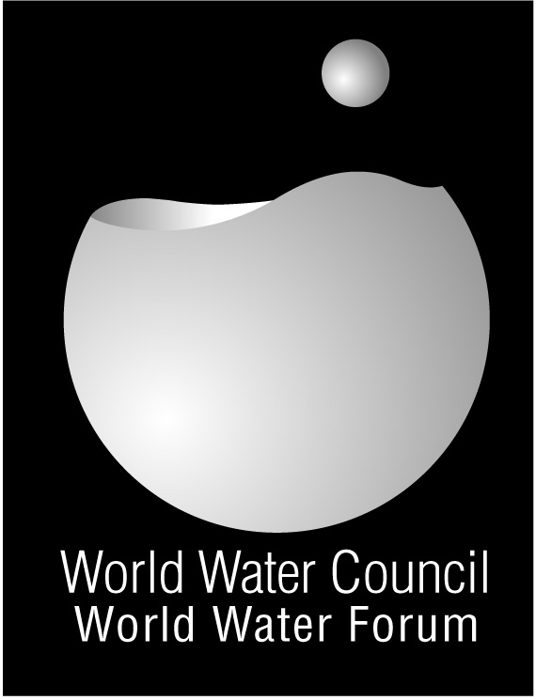

From Mexico to Istanbul

MOBILIZING STAKEHOLDERS AND POLITICIANS

Asia Pacific Water Forum: A Initiative involving politicians, scientists, scholars, university teachers and local representatives

Created in 2006, the APWF seeks to champion efforts aimed at boosting investments, building capacities and enhancing cooperation in the water sector at the regional level and beyond

Some achievements
The First Asia-Pacific Water Forum took place in Beppu City in Japan, on 3-4th December of 2007. The main theme was Water Security: Leadership and Commitment, and attracted 10 Heads of State and Government, 31 Ministers, and representatives from over 36 Asia-Pacific countries and regions.
Two documents were issued: Message from Beppu and Policy Brief 2007.

Water Safety Plans: A tool to improve health

The WHO Guidelines for Drinking-water Quality and the IWA Bonn Charter for Safe Drinking Water (2004) recommend the adoption of Water Safety Plans (WSPs) as a means of ensuring the safety of drinking-water. The WSP approach is a preventive risk management strategy, encompassing all steps in the water supply system. WHO and IWA have a long term agreement to jointly promote and support the scaling-up of WSPs.

Some achievements

- An international conference on WSPs took place in Lisbon, Portugal from 12-14th of May 2008 and attracted over 200 international delegates.
- The Water Safety Plan Manual has recently been published, which provides suppliers step-by-step guidance to develop and implement WSPs. To facilitate its wider access, the Manual is currently being translated into several languages, including Spanish, Chinese and Arabic.
- The Water Safety Portal (WSPortal) has been re-launched. This is a web-based platform to obtain WSP references, tools and case studies. (www.who.int/wsportal/en; www.wsportal.org)
- A common sector position document is currently in development. This document aims to harmonise the approach to supporting WSP implementation amongst key sector stakeholders and provide a means for commitment to further action.

Weblink:
http://www.apwf.org

Contact:
Mrs. Taeko Yokota
yokota@waterforum.jp

The three main themes pursued in the documents:

- Water Financing and
Capacity development
- Disaster Management
- Water for Development and Ecosystems

Latin America and the Caribbean region
In October 2008 a regional WSP network of experts was launched jointly by IWA, WHO / PAHO, USEPA, AIDIS, CDC and the US Department of State. This Network strengthens institutional support for water safety in the region and brings together water, health and development specialist and practitioners

In Asia
A number of partners – including IWA, WHO, AusAID, USAID, UNICEF and WSP / World Bank – continue to cooperate and support implementation of WSPs in rural and urban environments.
Web-link :
www.who.int/wsportal/en
www.wsportal.org
Contact person : Mr Tom Williams; Tom.Williams@iwahq.org

