Spotlight on Sanitation
World Water Day 2008

World Water Council

Water -

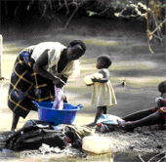

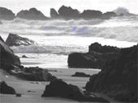

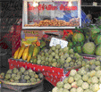

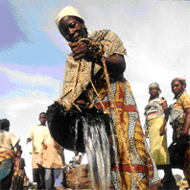

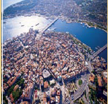

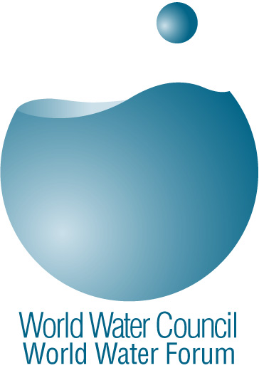

PRESS CONTACT
Daniella Boström
Tel : +33 (0)4 91 99 41 00
d.bostrom@worldwatercouncil.org
www.worldwatercouncil.org

- World Water Day p. 3

- 2008, International Year of Sanitation p. 4

- The World Water Council p. 6

- The World Water Fora p. 8

- Facts and figures on water p. 11

- Message from the President of the World Water Council
on the occasion of the World Water Day 2008 p. 12

I. World Water Day

The international observance of World Water Day is an initiative that grew out of the 1992 United Nations Conference on Environment and Development (UNCED) in Rio de Janeiro. By adopting a resolution, the United Nations General Assembly designated 22 March of each year as World Water Day. States were invited to devote this day to setting up concrete activities that would raise awareness on water related issues.

Since the first celebration, there have been all kinds of activities such as documentaries, conferences, round table discussions and seminars. Last year’s World Water Day focused on the theme of Water Scarcity.

This year, World Water Day will coincide with the International Year of Sanitation. The United Nations has officially declared 2008 to be the year to take action on a crisis that affects more than one out of three people on our planet.

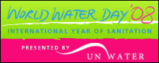
World Water Day 2008 will therefore put sanitation in the spotlight.
It is celebrated by the UN on Thursday 20 March.

II. 2008, International Year of Sanitation

Today 2.6 billion people, including almost one billion children, live without even basic sanitation. Despite the numerous initiatives supported by the United Nations, 42 000 people die every week as a result of poor sanitation.

To fight this crisis, a water supply target and a sanitation target were included in the United Nations Millennium Development Goals (MDGs) in 2000 and respectively in 2002. These targets aim to halve the proportion of people without sustainable access to safe drinking water and to basic sanitation by 2015.

To measure the progress toward these targets, the UN established two indicators:
- The proportion of population with sustainable access to an improved drinking water source, urban and rural
- The proportion of population with access to improved sanitation, urban or rural

Improved drinking water source is for example piped water into dwelling, plot or yard and improved sanitation is for example secure latrines.

In 1990, the number of people without improved sanitation was roughly 2.7 billion people. In 2004, it had only decreased to 2.6 billion. This means that the number of people without improved sanitation decreased by only 100 million between 1990 and 2004. The global MDG sanitation target will be missed by more than half a billion people if the trend 1990–2004 continues up to 2015 (Joint Monitoring Program for Water and Sanitation).

As these numbers show, it is urgent to address and to tackle the sanitation crisis –which is what the International Year of Sanitation will be doing throughout an entire year.

Financially speaking, “investing approximately $10 billion per year can halve the proportion of people without basic sanitation by 2015. If sustained, the same investment could achieve basic sanitation for the entire world within one or two decades,” read a UN press release on the official launch of the year.

Secretary-General Ban Ki-moon also highlighted the fact that the access to sanitation is deeply connected to all the Millennium Development Goals, in particular those involving the environment, education, gender equality and the reduction of child mortality and poverty.
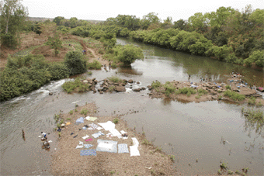

“Sanitation enhances dignity, privacy and safety, especially for women and girls,” the press release further stated. “Schools with decent toilet facilities also enable children, and once again especially girls, to remain in the educational system”.

According to the United Nations, improved sanitation facilities could reduce diarrhoea-related deaths in young children by more than one-third. If hygiene promotion is added, such as teaching proper hand washing, deaths could be reduced by two thirds.

During this International Year of Sanitation, major regional conferences will be held as part of capacity building initiatives. One of them will especially focus on school sanitation. The year will also encourage public and private partnerships to accelerate progress with the help of each sector’s strengths.

“Sanitation is not a dirty word; it is a critical factor in human welfare and sustainable development,” said Mr. Sha Zukang, Under-Secretary-General for Economic and Social Affairs. “We need to put the spotlight on this silent crisis.”

III. The World Water Council

The two main reasons for the creation of the World Water Council, 12 years ago, were to create international awareness at every decision making level and thereby advance the cause of water. Several international institutions were behind this initiative including UNESCO, the United Nations Development Programme (UNDP), the World Bank, the International Water Resources Association (IWRA), the International Commission of Irrigation and Drainage (ICID) and the International Water Association (IWA).

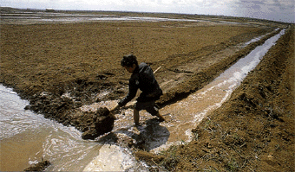

The World Water Council, created in 1996, currently brings together 350 organizations in nearly 70 countries. It gathers the “Water World” in its full dimension — governments and local authorities, United Nations agencies, international organisations such as the World Bank or the World Conservation Union (IUCN), private firms, universities and research centres, financing organisations as well as civil society representatives. These members constitute the basis for exchange and dialogue with one objective: to place water issues at the centre of all debates and to make water a priority for decision-makers.

The World Water Council’s mission
Facing water’s worst enemies: uncontrolled demographic change with exceeding migration, escalating urbanization with effects such as severe pollution, climate change and the natural disasters it provokes, the role of the World Water Council is to explain the necessity to efficiently conserve, protect, develop, manage and use water for human development and for the respect of the environment and for biodiversity.

The Council seeks to respond to the necessity to explain water’s essential role with regards to food production, health, industry, water-related services and the equilibrium of the ecosystems.

At times, these various needs prove to be conflictual, and they may create tensions that can only be resolved by dialogue.

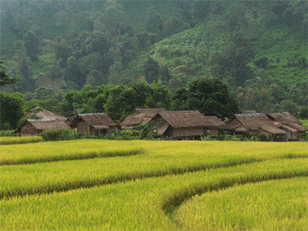

IV. The World Water Fora

Every three years, in close collaboration with the authorities of the host country, the World Water Council organizes the World Water Forum. Constituting the largest water-related event in the world its three main objectives are to:

- Make water a priority in the political and economic agenda worldwide;
- Facilitate and encourage in-depth debates on major water issues;
- Generate political commitment and bring the public’s attention to these commitments.

From Mexico to Istanbul
Following the Forum in Marrakech (1997), The Hague (2000), and Kyoto (2003), in 2006, the 4th World Water Forum was held in Mexico City on the theme Local Actions for a Global Challenge. The Forum highlighted over 1500 local actions that had been carried out by grass-root organizations.

“Beyond the reports and declarations, we felt a clear willingness to favor action both during the preparatory process and the actual Forum,”said Loïc Fauchon, President of the World Water Council.

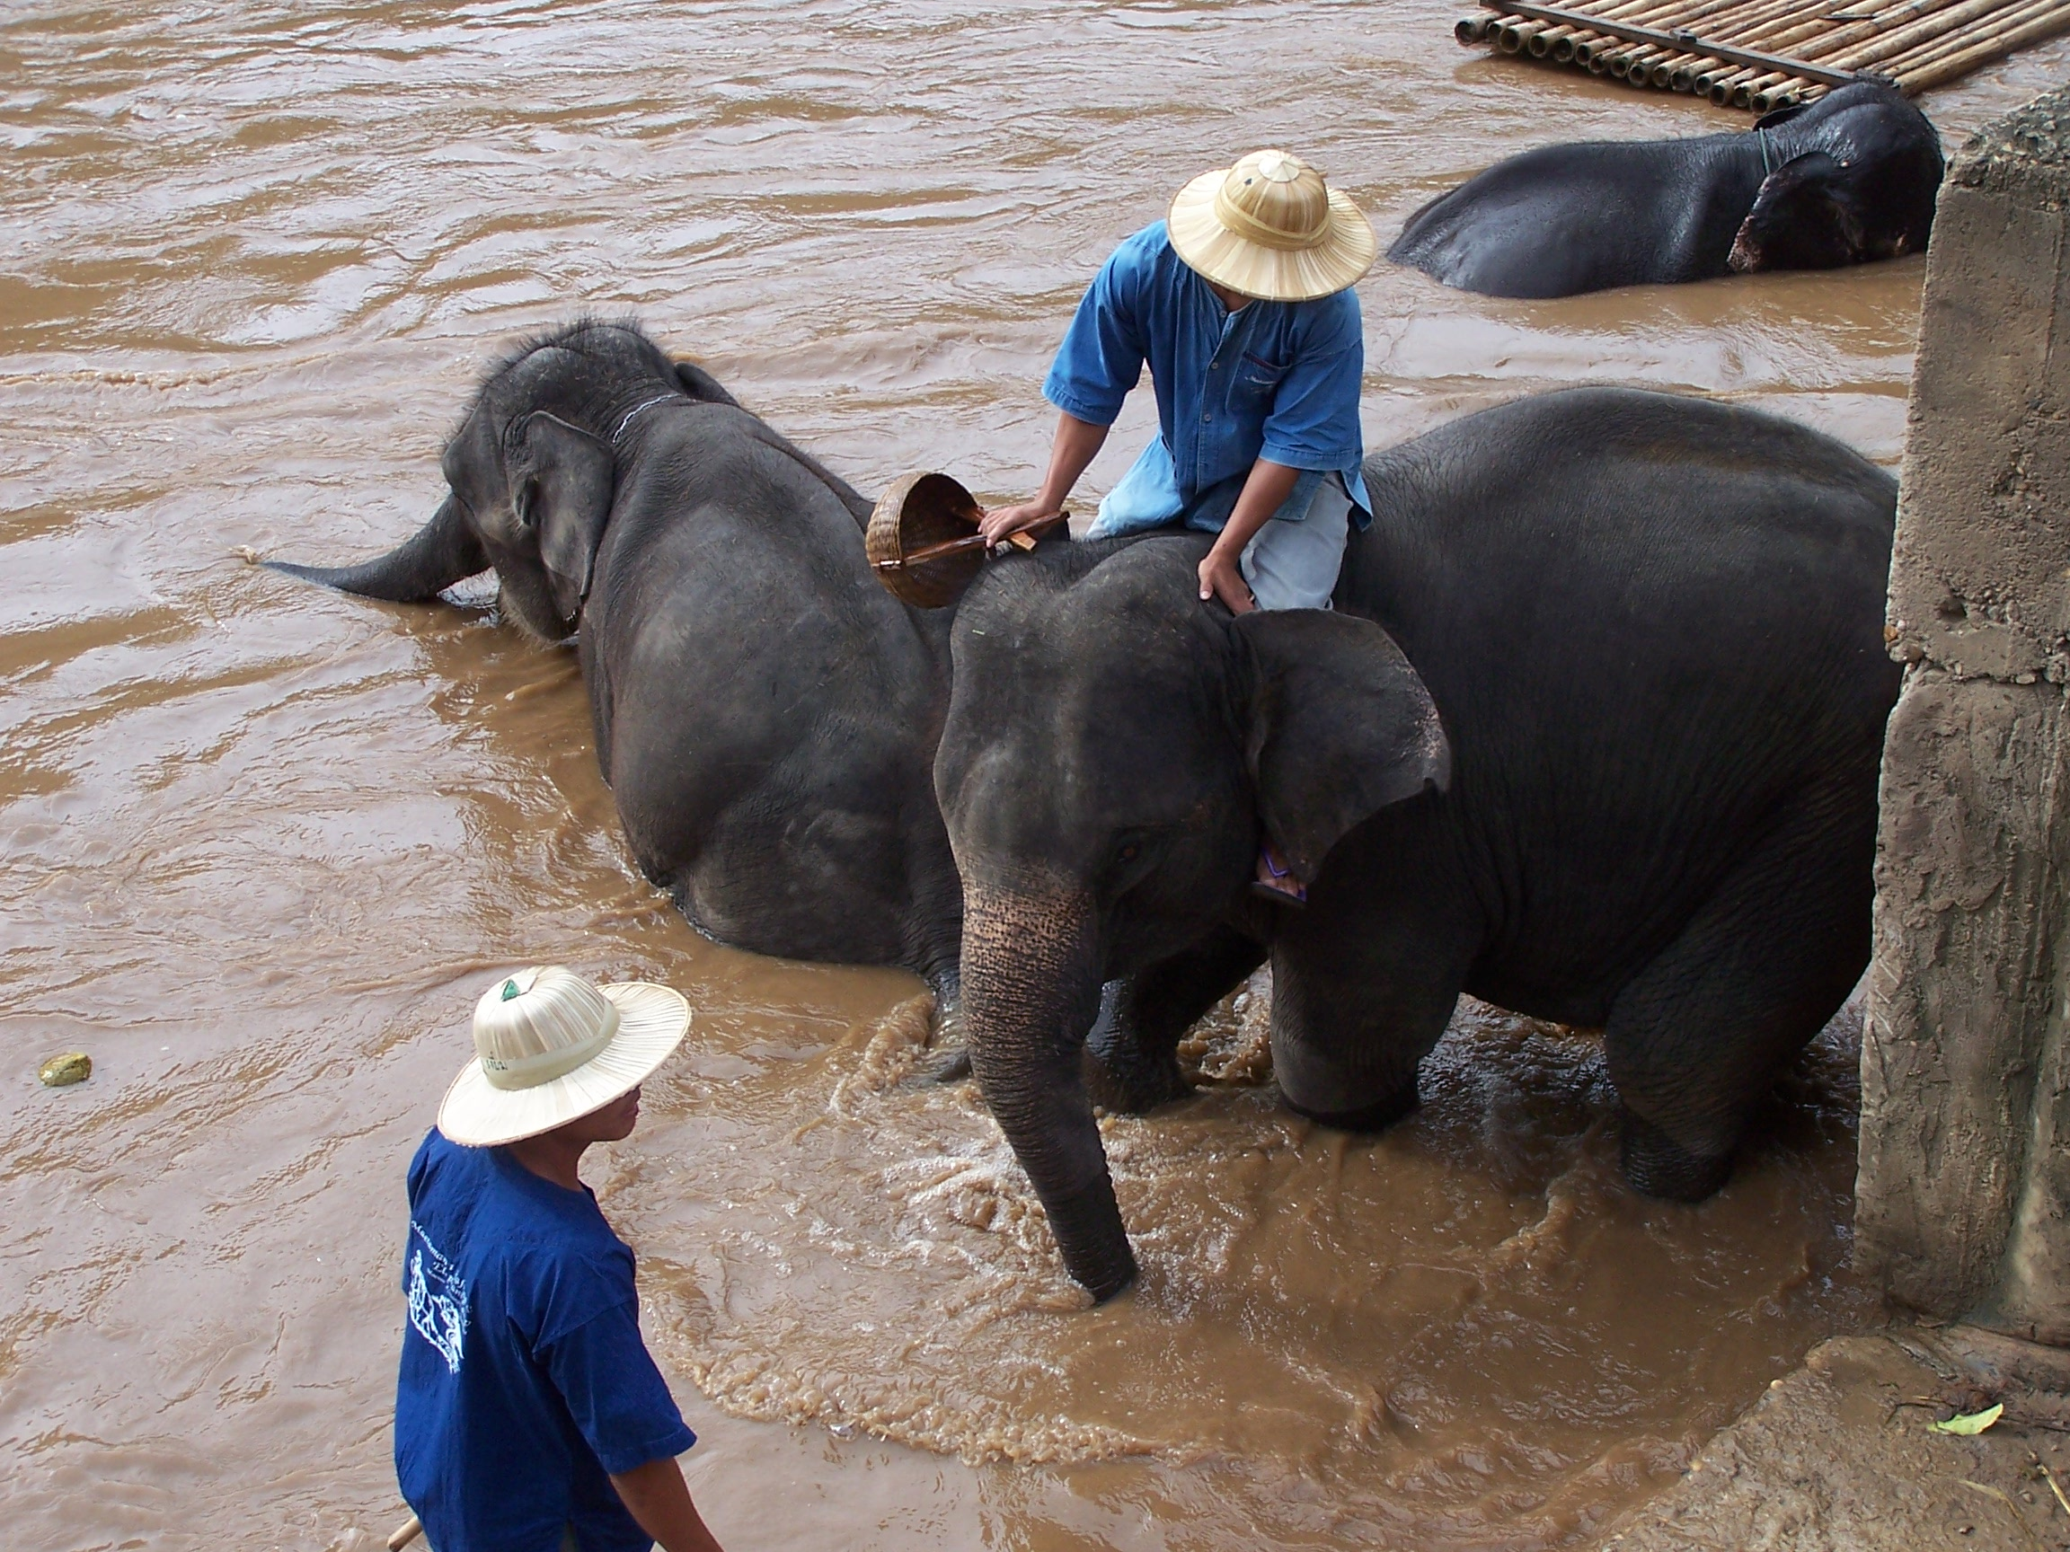
The Forum in Mexico also saw for the first time Ministers, Parliamentarians, local officials, NGOs, companies and international and professional institutions together sat around the same table. Everyone listened, reflected, spoke and made proposals – the majority in favor of a right to water.

After the 4th World Water Forum in Mexico, which had more than 20 000 visitors from five continents, Istanbul is preparing to host the 5th World Water Forum in March 2009.

This 5th edition will not just be a week of high-level meetings. For the past three years, Heads of States, citizens, scientists and professionals have worked in the spirit of the overarching theme of the Forum: ‘Bridging Divides for Water’.

Bridging divides for water underlines not only the geographical crossroads between Europe and Asia, the Middle East and Africa, North and South, represented by Istanbul, but also the barriers between modern-age and traditional water cultures and uses, as well as between rich and poor and between developed and developing regions of the world.

More than ever before, the 5th World Water Forum will focus on overcoming these economical, social, cultural and technical barriers that block human development.

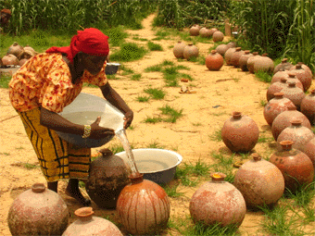
V. Facts and Figures on Water

- 1.2 billion people do not have access to safe drinking water

- 2.6 billion people do not have access to basic sanitation

- Every minute, 15 people die of a water-related disease such as cholera, diarrhea and typhoid. That represents about 8 million people per year.

- In Europe, more than 40 million people do not have enough access to safe drinking water.

- In 100 years, water consumption has been multiplied by 10.

- The daily water consumption per habitant in residential zones is 350 liters in North America and in Japan; 200 liters in Europe; and 10 to 20 liters in Sub-Saharan Africa.

- In 2025, two out of three people will suffer due to water scarcity
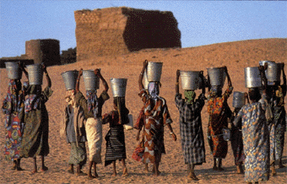

It takes

- 100 000 liters of water to produce 1 kilo of aluminum (26 400 gallons for 2 pounds of aluminum)

- 35 000 liters of water to produce 1 car (9 200 gallons of water to produce 1 car)

- 8 000 liters of water to produce 1 pair of shoes (2 100 gallons for 1 pair of shoes)

- 5000 liters of water to produce 1 kilo of paper (1300 gallons for 2 pounds of paper)

- 80 liters of water to produce 1 kilo of sugar (21 gallons for 2 pounds of sugar)

- 2 300 liters of water to produce 1 kilo of rice (600 gallons for 2 pounds of rice)

- 1 100 liters of water to produce 1 kilo of wheat (290 gallons for 2 pounds of wheat)
Loïc Fauchon, President of the World Water Council, frequently says:

- Water mobilizes 10 times less investment than new information and communication technologies

- The lack of water kills 10 times more people than wars. It blocks the establishment of public health system and blocks access to education. Without water there can be no development.

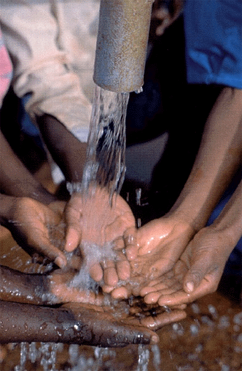

VI. Message from the President of the World Water Council on the occasion of the World Water Day 2008

Message from Loïc FAUCHON

Our planet doesn’t lack water. But this water so essential to life is not always available where and when we need it.

Scarce or polluted, water is running short for agriculture, for industry, for domestic uses, and for humankind. To satisfy the needs of water for food, water for health, water for development, we absolutely have to change the way we look at things, our relationship to water and, obviously, our behaviours and habits.

On this 20th of March, World Water Day, in a year dedicated to sanitation by the United Nations, we are challenged to face up to our responsibilities: in other words to plan for and manage the possible and often man-made shortages.

Firstly by tackling the causes namely the soaring population growth, the anarchic urban development and the upset climate. Secondly, by treating the effects namely migrations, pollution, flood events and many others.

All this calls for long term action leaving aside wishful speeches and demagogic decisions. After repeating over and over again that nature is depleting itself, we tend to forget that we are at the origin of this depletion. And while water and sanitation cannot go without science, the first thing they need is awareness.

We have to change mind-sets to convince decision makers and the general public that the issue is a moral one with a global dimension.

A moral issue since we cannot continue to leave three billion children, women and men stranded without taps or latrines. Access to water is a right and it is our urgent duty to ensure that this right is respected.

It is a global issue since, beyond essential human dignity, each country and each human community needs water to produce, to build and to maintain.

Changing mindsets means to convince that water is a common public interest issue, state by state and city by city.

But catching the mind is only worth it if it helps scrounge money. We are desperately short of money to treat, transport, distribute and purify water.
This boils down to making budgetary, accountancy and financial choices, all in all, political choices. Whether the money comes from large banks or from micro-credit institutions, loans or donations, the amounts dedicated to water will keep on growing because the needs are immense and the necessity is permanent. Surely, the cost of water can drop here and there but hydraulic investment budgets will keep increasing everywhere.

The water community which has been mute until now, must work at justifying these costs and budgets while convincing political instances that water trucks are better than tanks.

The issue of the energy needed for water gives its full meaning to the notion of political courage and is a matter of great urgency. Without energy, without electricity, there is no pumping, no storage and no treatment. Yet, we do lack energy for water.

The recent increase in its cost, especially in the poorer and landlocked countries, deprive part of the population of access to the resource. In places like the bush of Benin or Mali where we use to pump for eight hours non stop three years ago, we can now barely pump for three hours and at the same cost.

For hundreds of millions of people, solving this problem is a question of survival. Finding suited solutions demands that we mobilise our intelligence and willpower.

Intelligence to invent new technological solutions through the development of alternative energy sources that, in the future, will help make more water available with increasingly less energy. I am sure that our scientist and engineers, with their genius and know-how, will see to that. But this is not enough…

Willpower to convince that a share of the energy for water needed by the destitute must be provided at a reduced cost. Can we be talking of putting a stop to the increase of part of oil prices? Is there a specific oil product that could be dedicated to access to water? Or should we think of an energy for water tax?

The World Water Council is working on this issue with the aim of formulating concrete proposals for a new type of financing which shows solidarity, is sustainable and fair.

No doubt we are running late to reach the famous Millennium development goals. But it is paramount to convince humankind that it cannot afford to go without a genuine water policy.

On this World Water Day, it is this Voices that need to be spread. A Voice that can contribute to match the hopes of the poor to the imperatives of the wealthy.

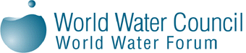

Photo credit : Unesco, Davis Blaine,
Laetitia Chassefière, Tristan Clements

World Water Council
Espace Gaymard
2-4 place d'Arvieux
13002 Marseille, France
Tel: +33 (0) 4 91 99 41 00
Fax: +33 (0) 91 99 41 00
www.worldwatercouncil.org

