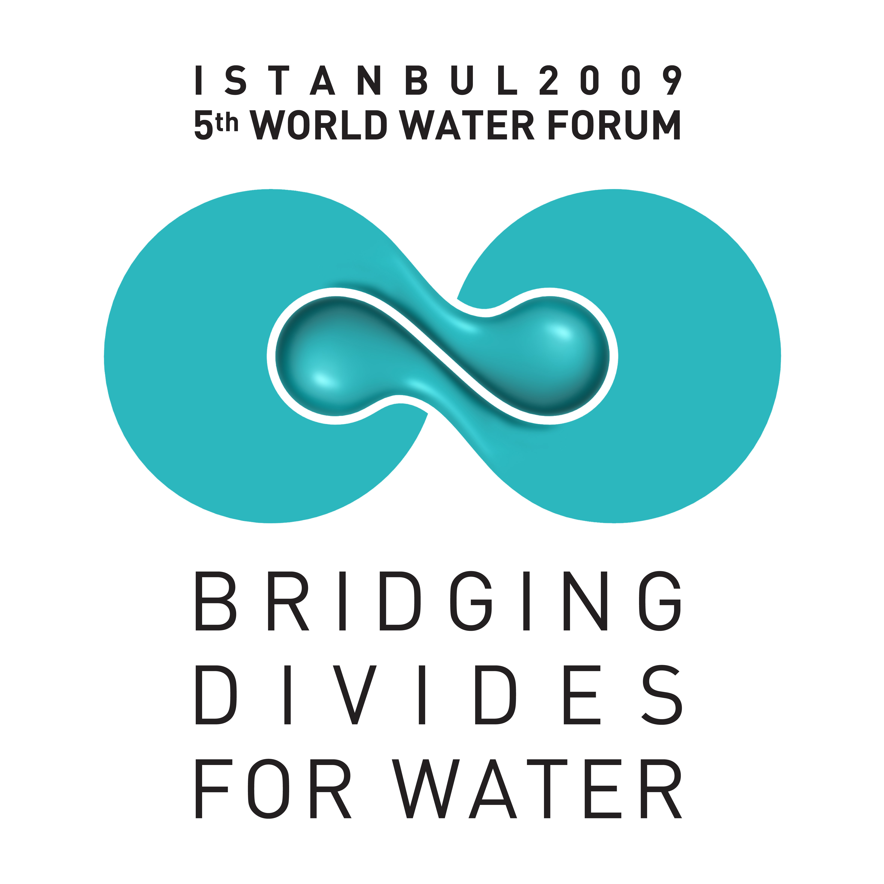
5th WORLD WATER FORUM

REGIONAL PROCESS

28-29 May 2008

Bishkek, KYRGYZSTAN

“CLIMATE CHANGE, WATER RESOURCES MANAGEMENT, GOVERNANCE AND
CAPACITY BUILDING ISSUES IN CENTRAL ASIA”

FINAL DOCUMENT

The Third Regional Preparatory Meeting of the Fifth World Water Forum took place in Bishkek on 28-29 May 2008, with the participation of more than 200 people from 13 countries. The meeting was hosted by the Ministry of Agriculture, Water Management and Processing Industry of Kyrgyzstan, the Ministry of Environment and Forestry of Turkey, the Interstate Coordination Water Commission of Central Asia and the Global Water Partnership Central Asia and Caucasus. Ministers from Kyrgyzstan, Turkey, Tajikistan and Turkmenistan attended to the meeting. Presentations were made by Armenia, Azerbaijan, Georgia, Kazakhstan, Kyrgyzstan, Tajikistan, Turkmenistan and Turkey, as well as by the representatives of the ICWC, EC IFAS, and regional offices of SDC, IWMI and ADB. Roundtable meetings followed by many experts from the countries of the region sharing similar problems were fruitful and provided guidance for managing and protection of water resources to meet human and environmental needs. Many interesting ideas and comments have emerged in this context.

The major points raised in this regional meeting are as follows:

Theme 1: Climate change effect on water resources in Central Asia

Climate change, population growth, industrialization, urbanization and deforestation create huge stress on the water resources of the region.

Glacier melting in the mountainous areas due to the global warming is resulting in floods in the rivers and lakes. On the other hand, glacier melting has supported until now proper additional water resources in rivers, but reducing of volume of glaciers cause expectation that in next 20 years flow of Amudarya and partly some tributaries of Syrdarya and Zarafshan rivers can fail on 25-30 per cent, that will present big challenge to the region.

Understanding the effects of the climate change is central for developing regional and national adaptation strategies. Water storage and integrated water management are important elements in that respect. CO₂ emissions should be decreased by using renewable energies, hydro-energy in particular. Re-use of the waste water and utilization of the modern irrigation techniques are essential for water saving. Furthermore, public awareness should be created on the adaptation strategies.

Hydro-meteorological data and information should be collected regularly. Observation, measurement and monitoring networks should be improved.

The scale of tasks and problems on mitigation of influence of the climate change is rather great and covers almost all spheres of the human life. This problem in aggregate with the drying Aral Sea should be given the priority attention in the region. Mitigation and overcoming of these crises require mobilization of the efforts of all stakeholders and more harmonious cooperation of the Central Asian countries. In this context development of the regional document on the climate change effect on water resources, including recommendations on taking of adaptation measures for mitigation of the climate change impacts and its presentation during the 5th World Water Forum within the framework of the special session is very important."

Theme 2: Basin management and trans-boundary cooperation
The region is relatively rich in water resources, but there are many trans-boundary rivers. However, as it is expected that water stress in the region will increase gradually due to the negative effects of the climate change and pollution, cross-border cooperation is essential in order to address water problems of the region. Main focus is on the access to clean drinking water, irrigation for food security and energy generation.

Trans-boundary dialogue and cooperation in the region for the last 16 years has permitted to avoid any serious conflict for water delivery to different states and zones, even in previous water scarce and flooding years. Nevertheless, the existing cooperation among the countries of the region is not sufficient and must be improved. Although political will generally exists, the lack of understanding and confidence at the technical level is the main barrier to enhance cooperation. Regional program of consensus building dialogues at different levels could be developed so as to merge different views and positions. Exchange of reliable data and information is crucial. Furthermore, international mechanisms should work coherently to strengthen and advance trans-boundary cooperation.

Cross-sectoral interests of hydropower, irrigation and environment requires strengthening of legal and institutional framework of cooperation, same as use of financial tools that would account of sharing benefit, expenses and compensation of damage. This calls for comprehensive basin development plans, which need to be developed with stronger participation of all riparian countries and should be based on IWRM principles. Promotion of regional and sector dialogues oriented specifically towards long-term development of the region as a whole and stronger adherence to agreements by member countries is a must in order to merge different sectoral and country priorities on water use with the interest of society and nature.

The Chu-Talas experience can be taken into account particularly in small trans-boundary rivers. Inter-national Commissions should be established by the riparian states in order to manage trans-boundary water resources in an equitable and sustainable manner. Integrated water management plans could be developed at the basin level. However, good management of water resources at the national level is central at first. All stakeholders should be included in this process and bottom-up approach need to be followed.
Also, the discussions reflected that there is a need for a reliable system of data capturing, information sharing and training based on successfully implemented regional projects improving water management with IWRM, SCADA systems, etc.
It was suggested that “strengthening of international water law” should be a subject of discussion on the 5th World Water Forum."

Theme 3: Water resources governance (organizational aspects of efficient water management)

Water resources management and governance should be reformed in the region. Content and phases of the reform, from the decentralization point of view in particular, is as follows;

- Trans-boundary level (Aral Sea basin, agreements, strengthening of organizations on regional/basin level, ecosystem demands, economical tools – cost and benefits sharing, information exchange, water demand and limitation)
- National level
- Basin level
- System level
- Water users association level

Decentralization of water resources management in line with the economic reforms, mostly in agriculture sector, requires the tools and instruments for all inclusive (states, sectors and stakeholders) and good governance such as;

- Institutions
- Legal and regulatory framework (development and harmonization)
- Economic tools (what is state share and what are the boundaries of responsibility, financial mechanisms – tariffs, subsidies, privilege loans, incentives for water saving and resources protection)
- Technical and technological aspects (hydrometrics, automation, water allocation tools)
- Environmental needs (pollution control, ecological releases, water protection zones)
- Capacity building (equipment, training, including study tours)

Integrated water resources management is an important concept for bridging water users (sectors, states, downstream-upstream), water providers (states, decision makers, sectors) and stakeholders.

Theme 4: Capacity building and education

Training of the trainers is crucial in the region. Furthermore, education of the technical people as well as the women and children is central. Integrated training programs could be developed at the regional level.

Joint and reliable hydraulic and hydrological data bases should be established. Information exchange on the standards ought to be ensured. Technological innovations should be followed regularly. Partnerships can be developed for capacity building. New models and techniques should be applied in order to utilize water resources in an equitable way.

Strengthening regional cooperation, particularly in the Aral Sea Basin, could include the following;

- Institutional and legal aspects
- Training activities
- Information systems and data base
- Integrated water resources management
- Introduction of the automation systems
- Modeling tools for decision support systems

Furthermore, public awareness and concern on water issues should be created. NGOs involvement and media attraction are essential to this end.

